**Associate Cloud Engineer: Learning Phase 1 Deep Dive Channel (2020)**

**Course: Google Cloud Fundamentals for Azure Professionals**

**Module**: Getting Started with Google Cloud

GCP Fundamentals: Getting Started with Cloud Marketplace - Windows

<https://googlepluralsight.qwiklabs.com/focuses/10210644?parent=lti_session>

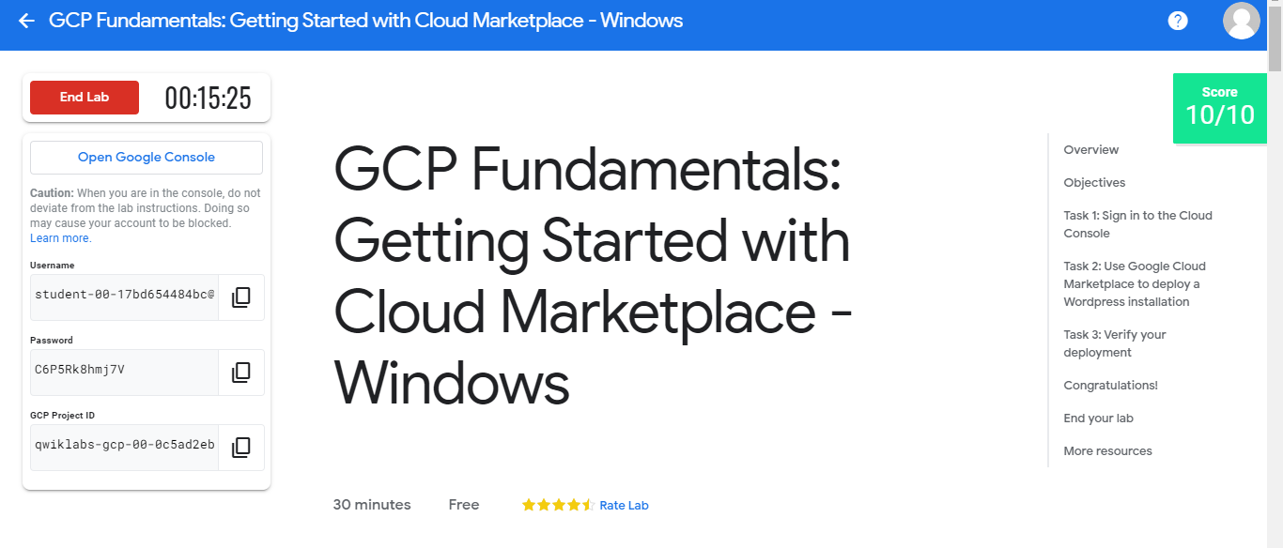

**Module**: Virtual Machines in the Cloud

GCP Fundamentals: Getting Started with Compute Engine - Windows

<https://googlepluralsight.qwiklabs.com/focuses/10210667?parent=lti_session>

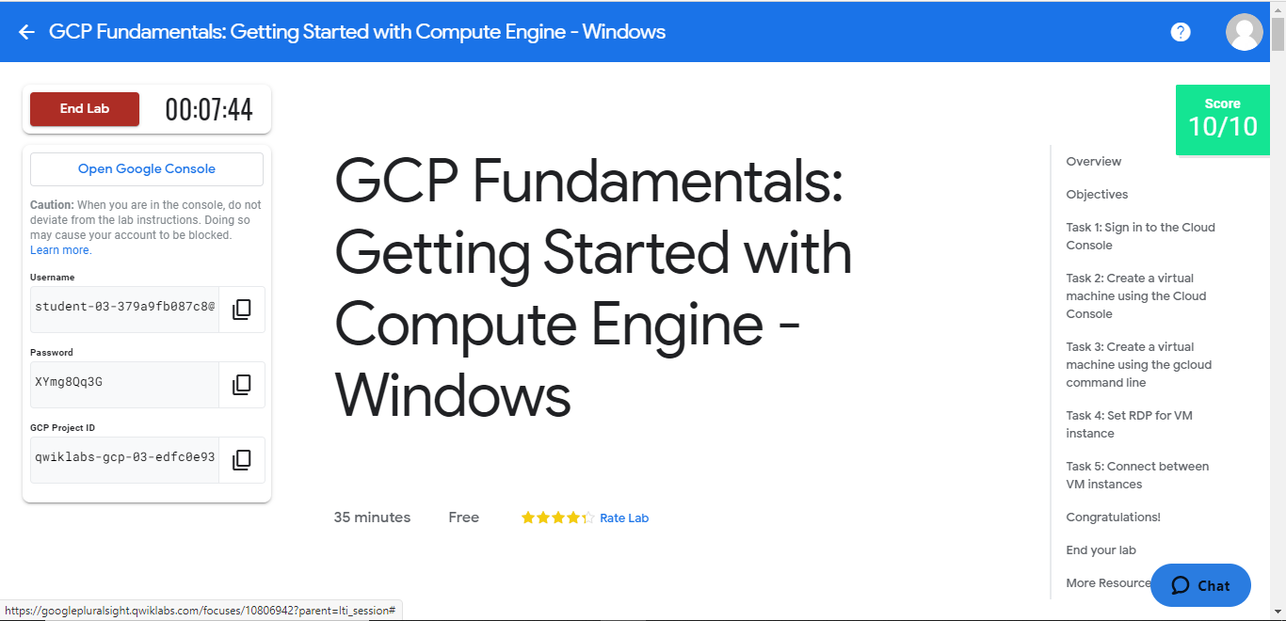

**Module**: Containers in the Cloud

GCP Fundamentals: Getting Started with Kubernetes Engine - Windows

<https://googlepluralsight.qwiklabs.com/focuses/10210696?parent=lti_session>

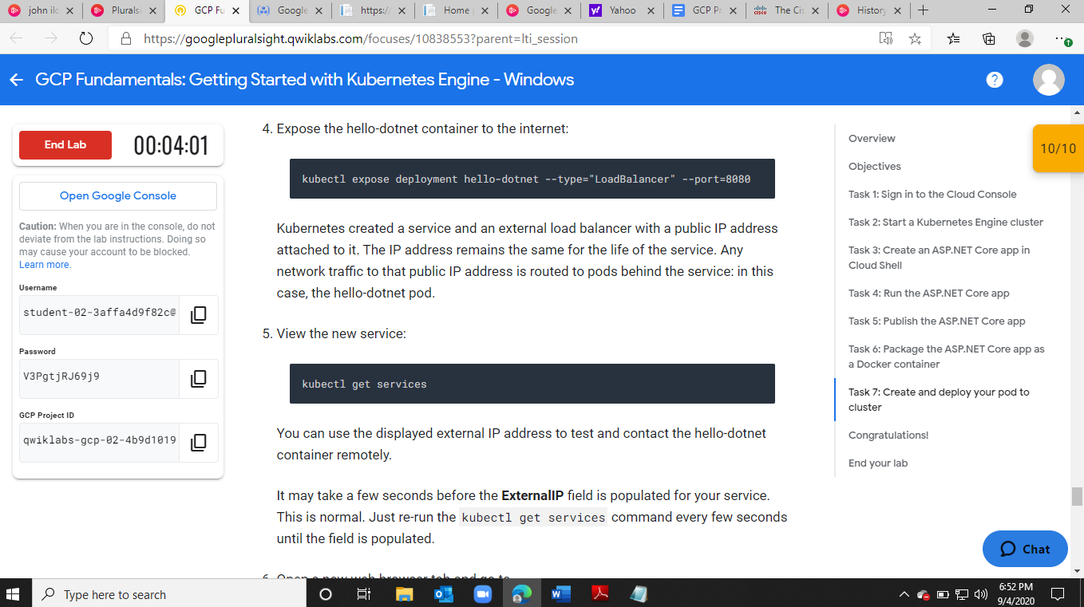

**Module**: Developing Deploying and Monitoring in the Cloud

GCP Fundamentals: Getting Started with Deployment Manager and Stackdriver - Windows

<https://googlepluralsight.qwiklabs.com/focuses/10210708?parent=lti_session>

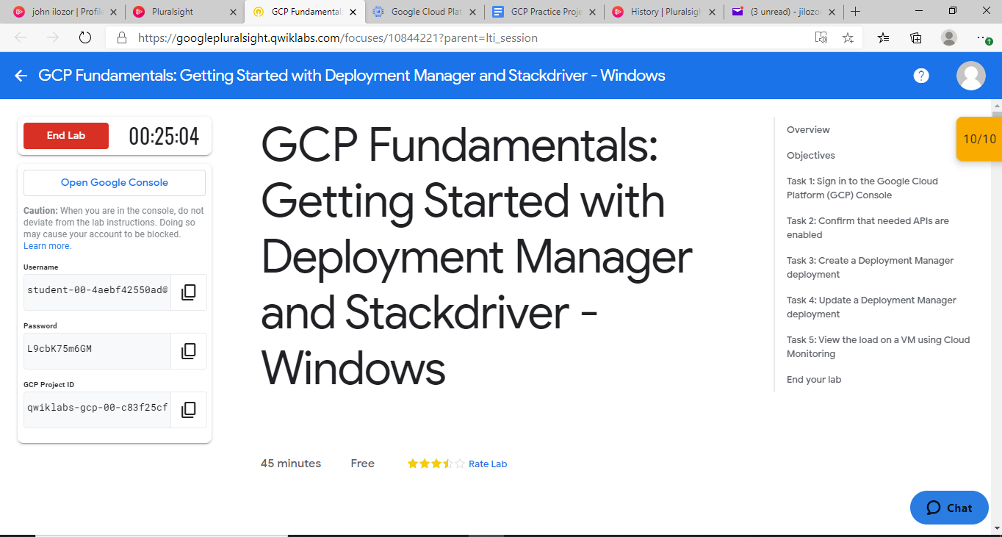

**Module**: Big Data and Machine Learning in the Cloud

GCP Fundamentals: Getting Started with BigQuery

<https://googlepluralsight.qwiklabs.com/focuses/10211123?parent=lti_session>

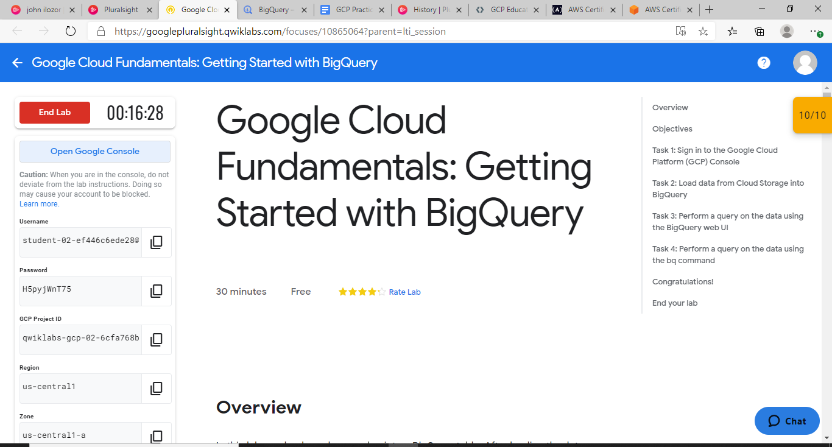

**Course: Securing and Integrating Components of your Application on Google Cloud**

**Module**: Using Cloud Pub/Sub

App Dev - Developing a Backend Service: Node.js

<https://googlepluralsight.qwiklabs.com/focuses/10217651?parent=lti_session>

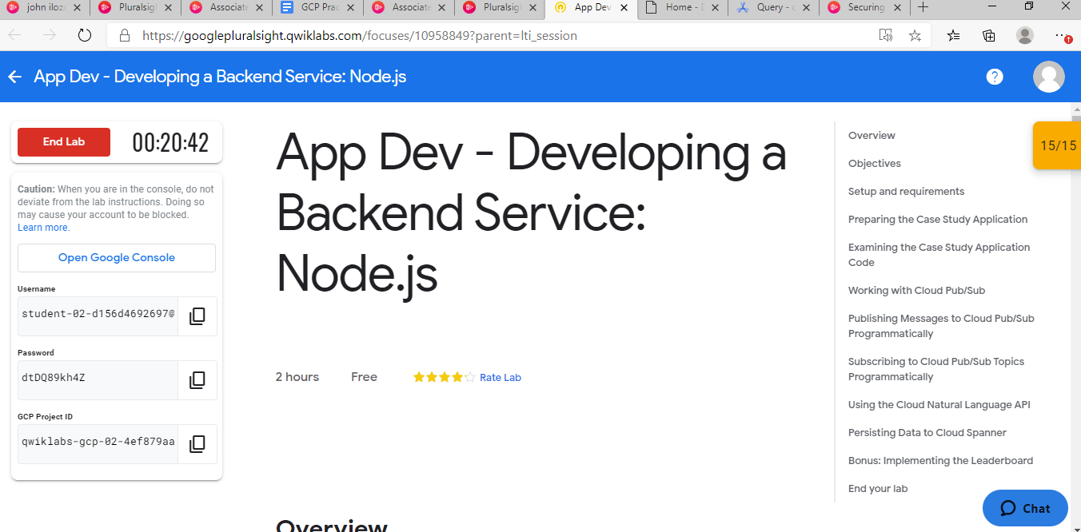

**Module**: Using Cloud Functions

App Dev - Processing Cloud Pub/Sub Data using Cloud Functions: Node.js

<https://googlepluralsight.qwiklabs.com/focuses/10217691?parent=lti_session>

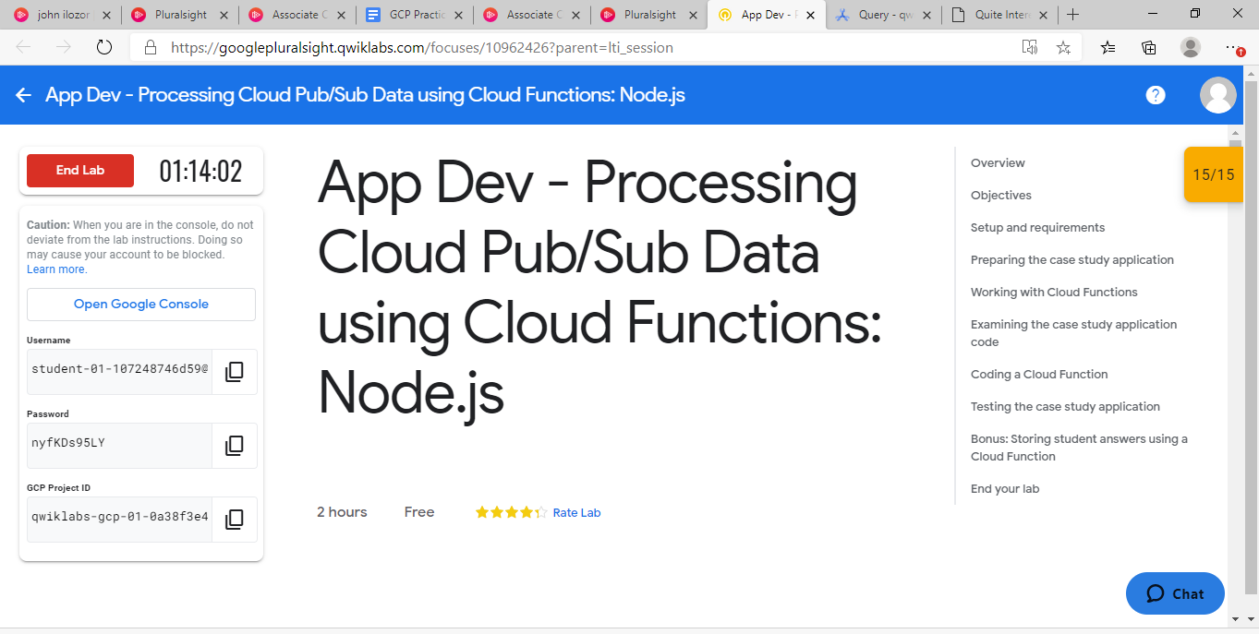

**Module**: Using Cloud Endpoints

App Dev - Deploying an API for the Quiz Application: Node.js

<https://googlepluralsight.qwiklabs.com/focuses/10217708?parent=lti_session>

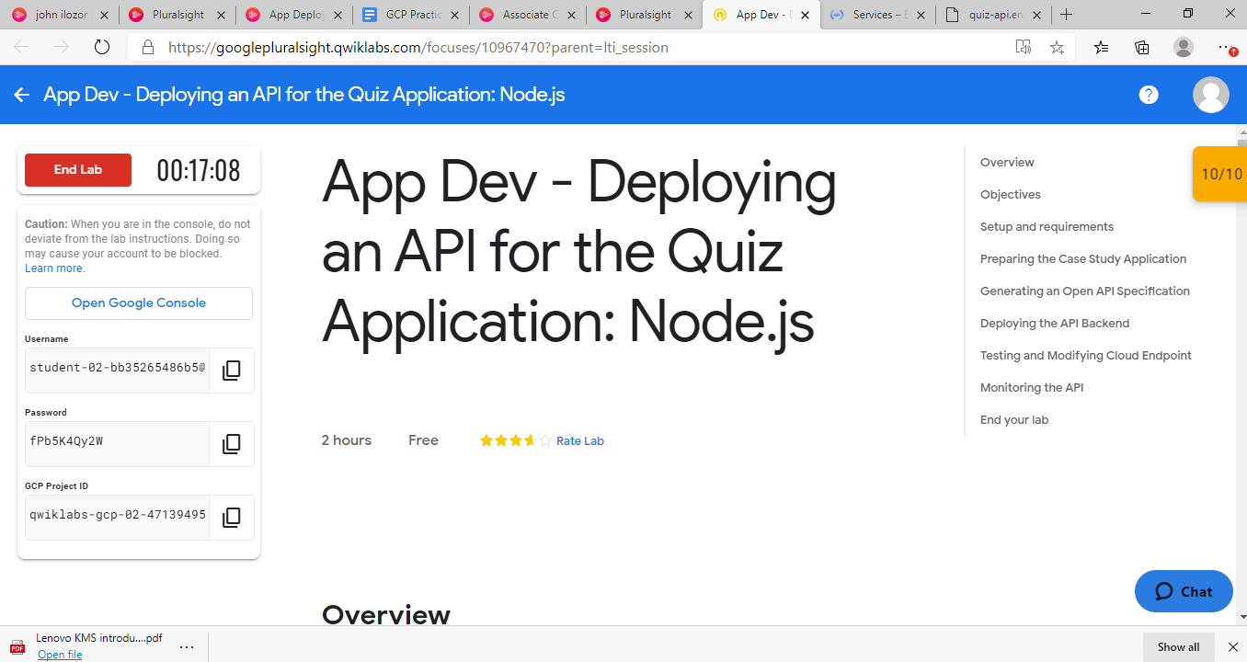

**Course: Google Cloud Platform Fundamentals - Core Infrastructure**

**Module**: Virtual Machines in the Cloud

GCP Fundamentals: Getting Started with Compute Engine - <https://googlepluralsight.qwiklabs.com/focuses/10169417?parent=lti_session>

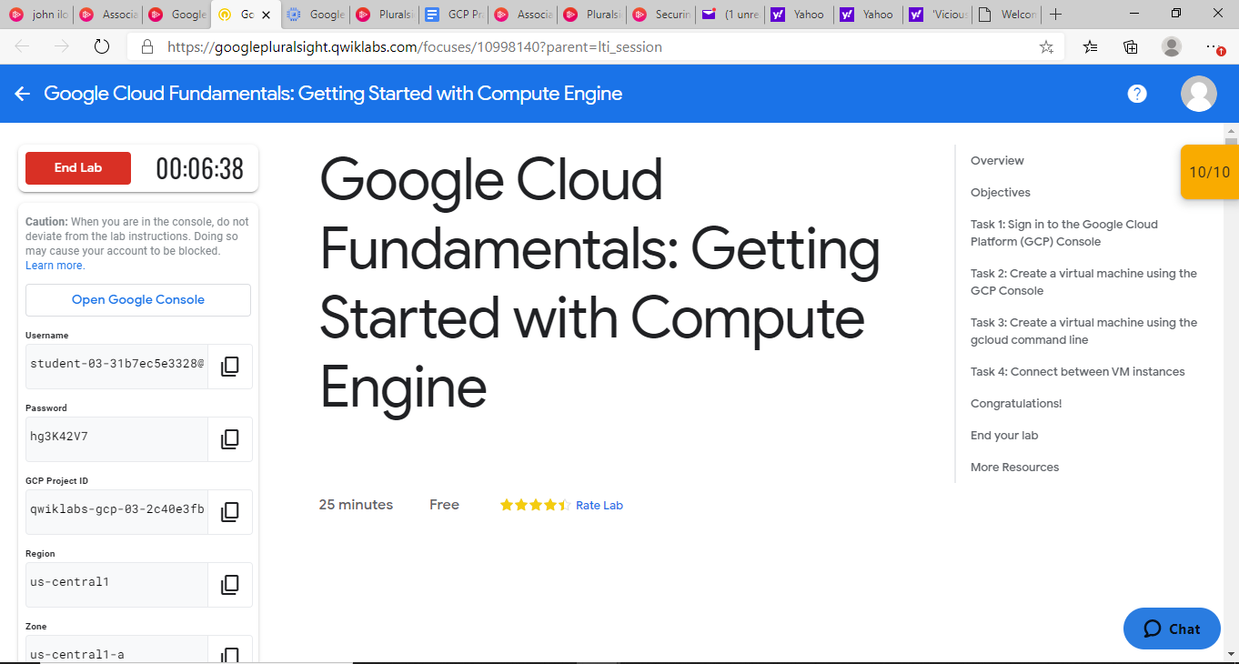

**Module**: Storage in the Cloud

GCP Fundamentals: Getting Started with Cloud Storage and Cloud SQL - <https://googlepluralsight.qwiklabs.com/focuses/10169431?parent=lti_session>

